Writing Task:

How has technology affected your language in the last ten years? What are some of the changes?

Use the mind map below to plan out some of your ideas

Technology has change my language

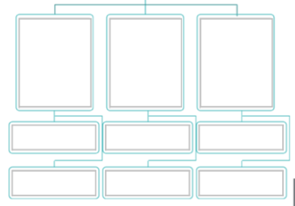

Written Response:

Essay Check List
- Do you have an introduction
- Are there three sentences in your introductory paragraph : General statement; your opinion; thesis statement
- Do you have two body paragraphs
- Does each body paragraph have a supporting reason and three examples
- Do you have a conclusion
- Does your conclusion include a concluding phrase
- Have you restated your opinion in your conclusion and summarized your reasons
- Have you used the past tense
- Have you re-read what you have written to make sure it makes sense
- Have you used punctuation
- Do your sentences have full stops and capital letters
- Are your paragraphs clear

