Reading Exercise:

You have found the following texts, which may be useful to you as you write the essay. In pairs skim read the texts to identify the main points relevant to the essay title below:
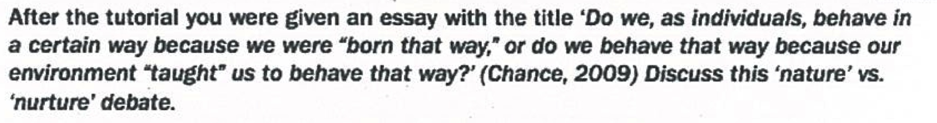
Student A, read texts 1-4 and Student B, read texts 5-9. Make brief notes so that you can report back to your partner what you have read.

Student A

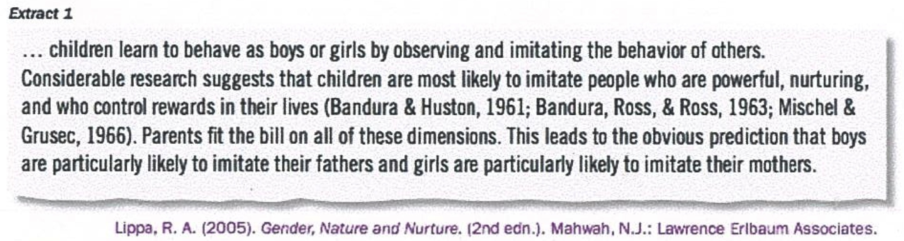
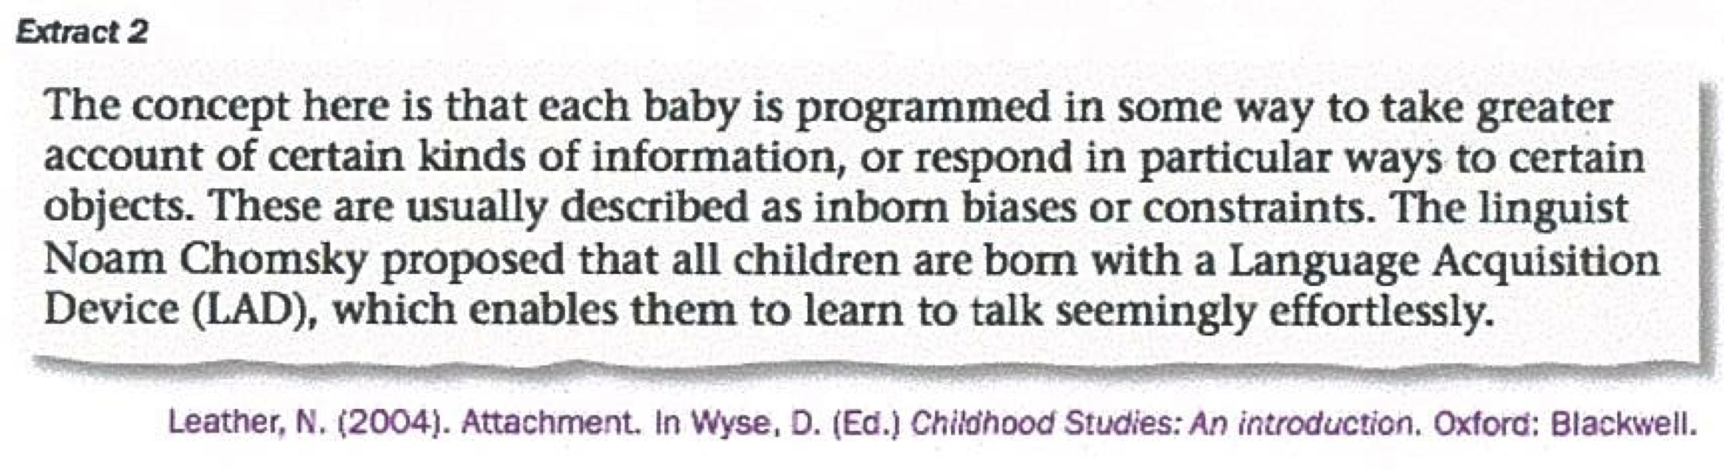
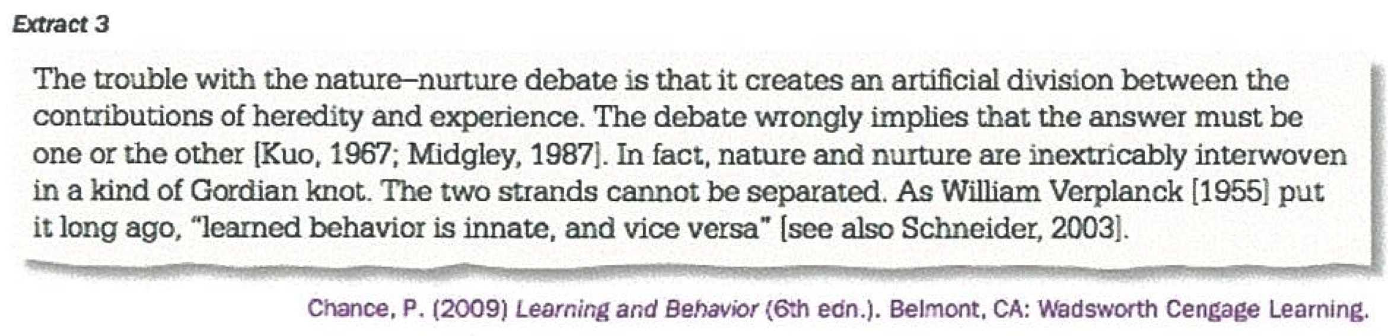
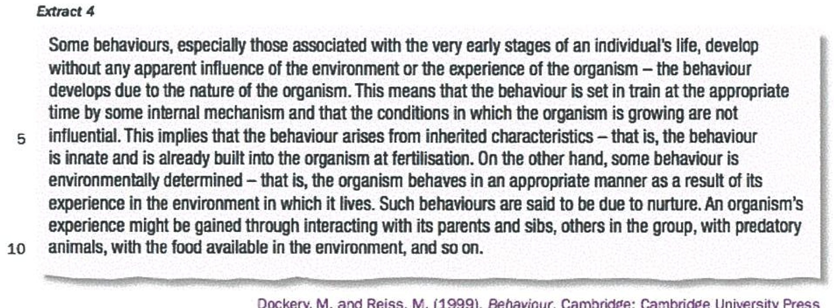
Student B

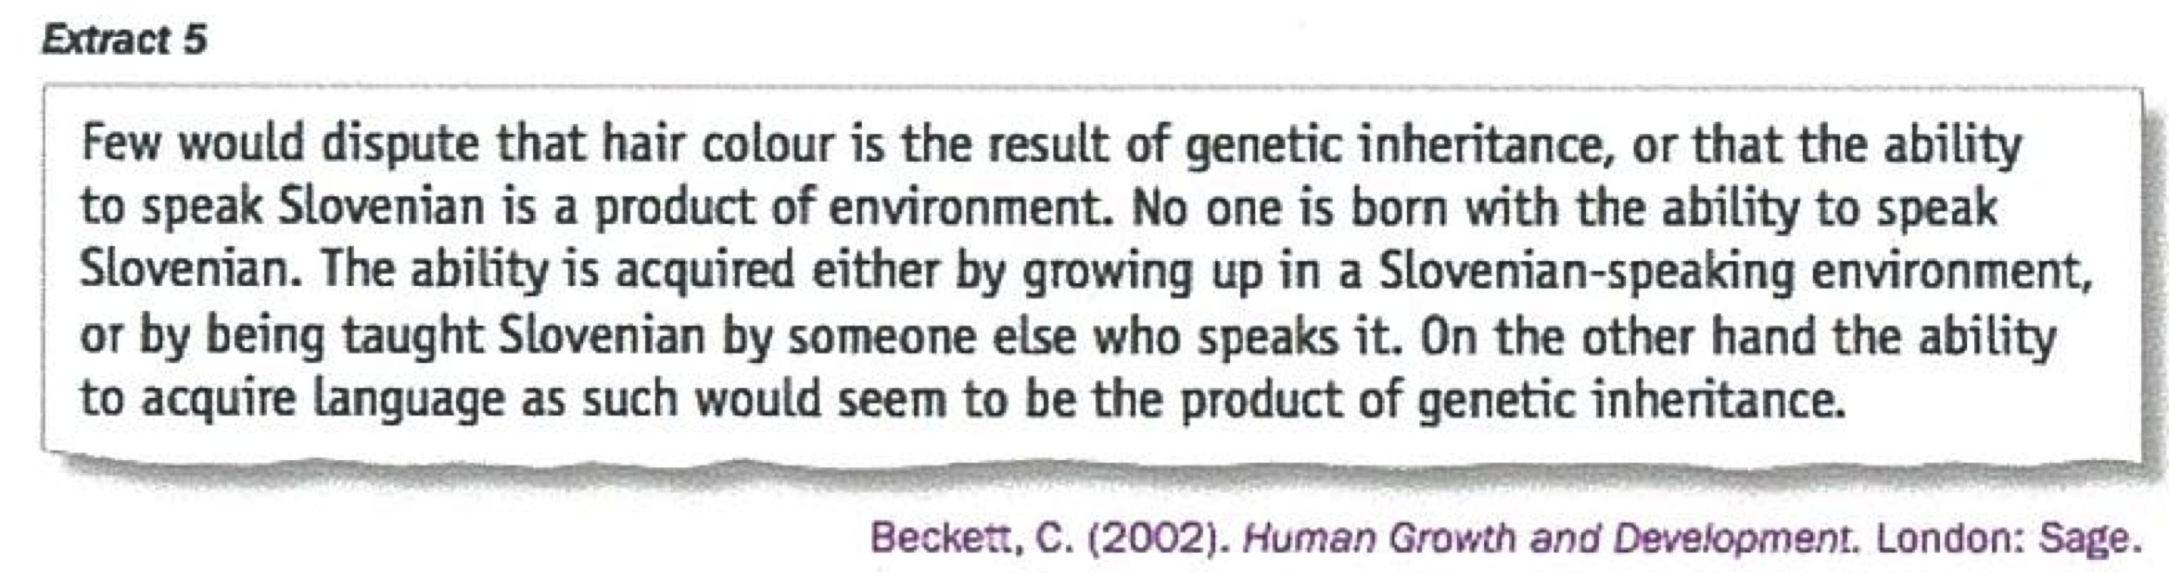
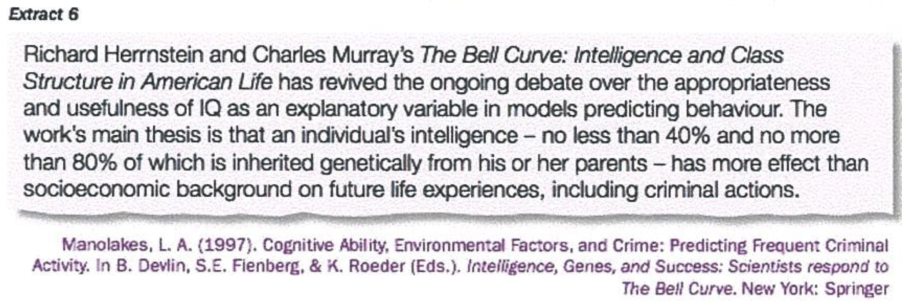
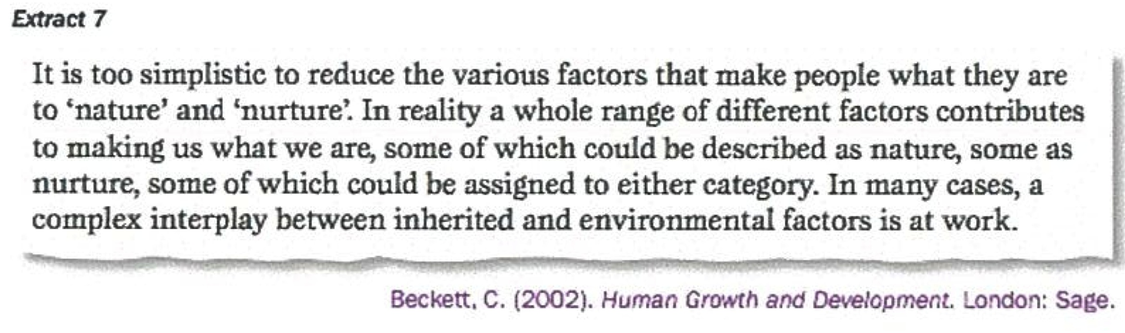
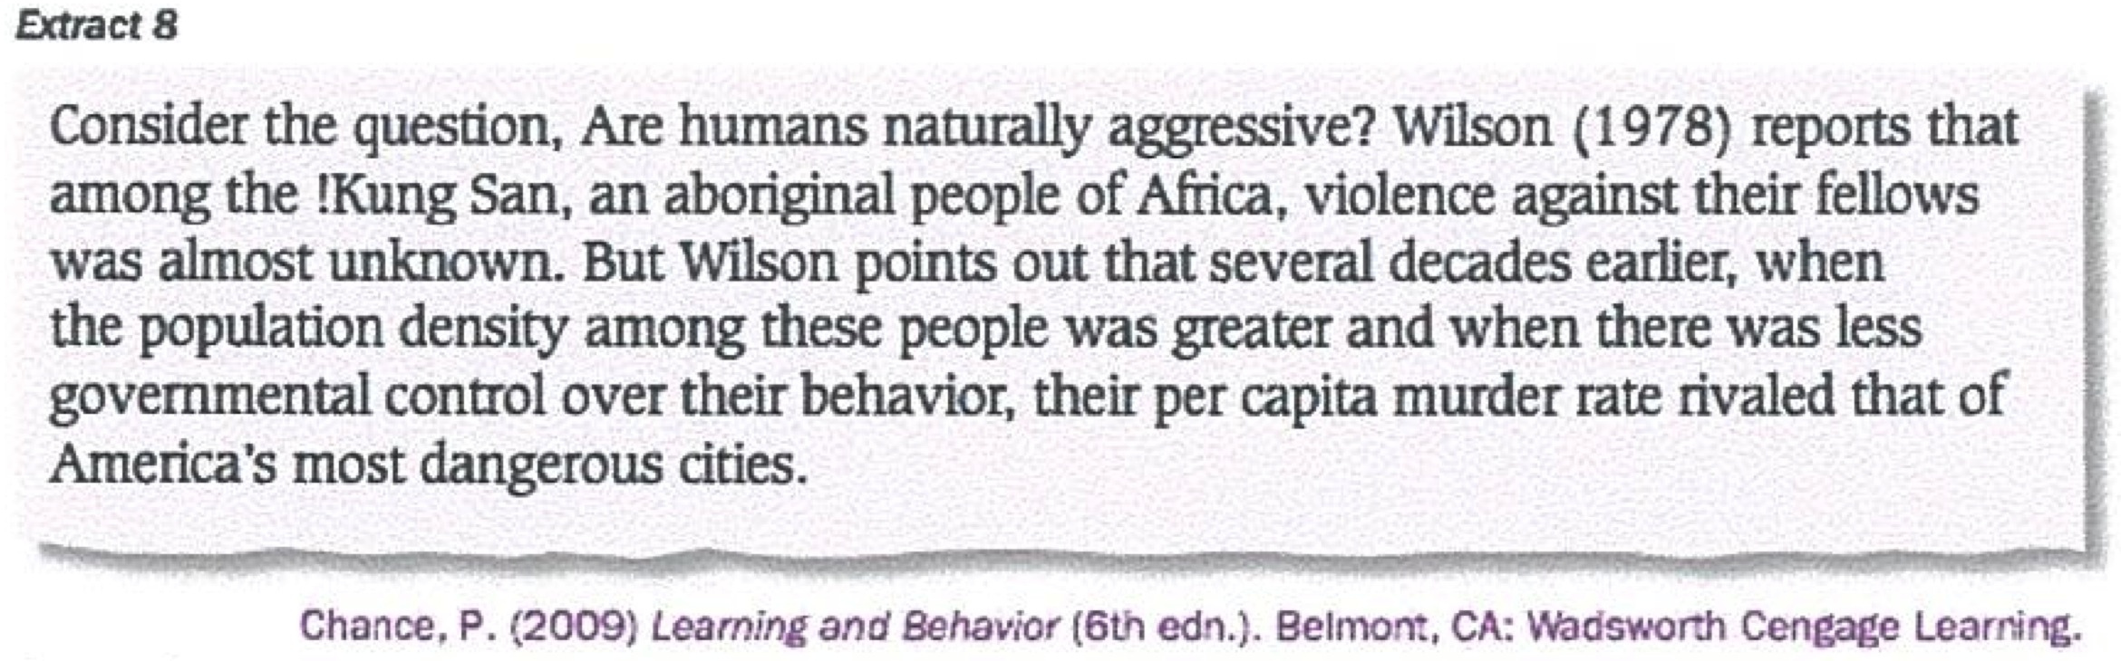
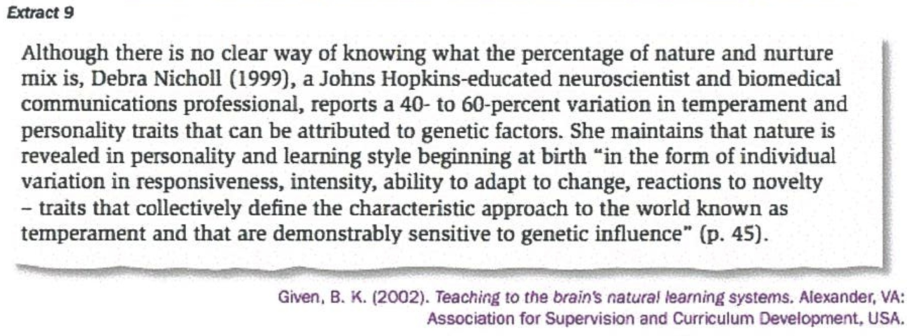
C. In pairs, summarize what you have read and produce a list of the main points from all nine texts that are relevant to the essay shown below:

Organize the main points so that they form the outline of the introduction and body of an essay

