Study Figures 1 and 2 below and answer the questions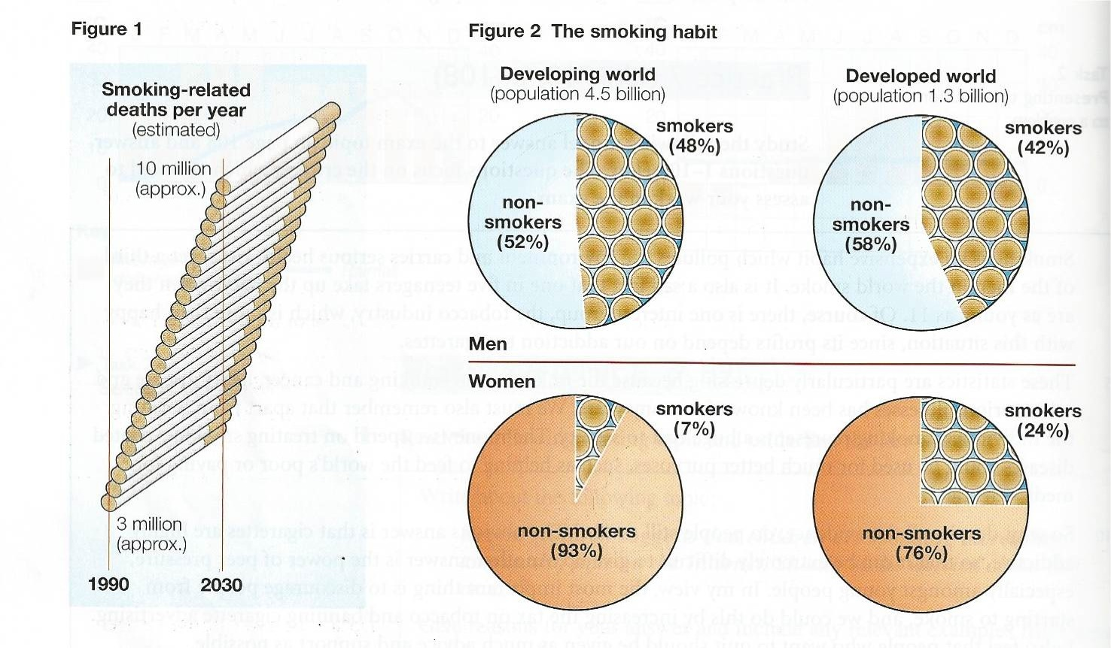

- What is the subject of figure 1?

- What period of time is covered in figure 1?

- In figure 2 what do the two circles above the line represent? And the two below?

- What do the two circles on the left represent? And the two on the right?

Now answer the questions below:

- Describe the change, which is show in figure 1.

- According to figure 2, generally speaking, who smokes more-men or women?

- Which group represents the largest percentage of smokers? What is the figure?

- Which group represents the smallest percentage of smokers? What is the figure?

- Compare male smokers in the developed world and developing world. Use: There are …. more….

- Compare female smokers in the developed and developing world. Use there are …. x times more …

Using the information from the exercises summarize the data shown in figures one and two on page 1

