You have found the following texts for an essay with the title “Discuss differences in gender roles in different cultures”

- Skim both texts to identify the main points relevant to the essay title
- Make brief notes so that you can report back to your partner what you have read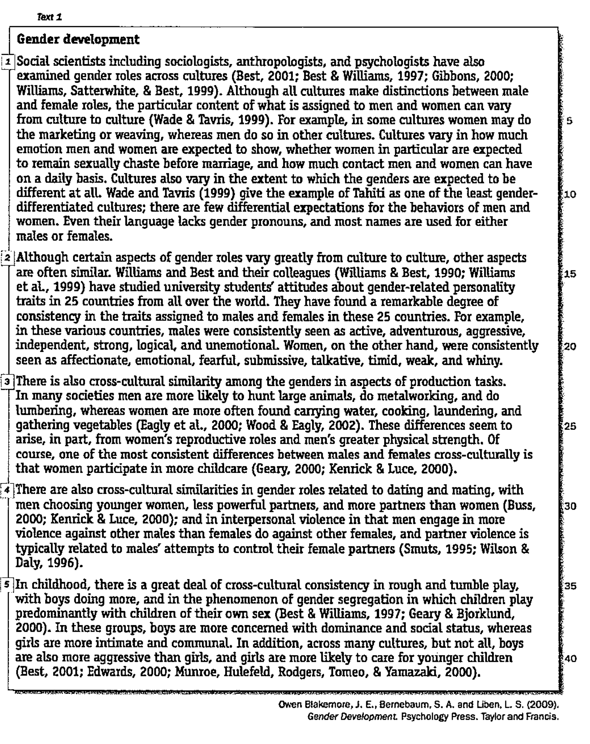
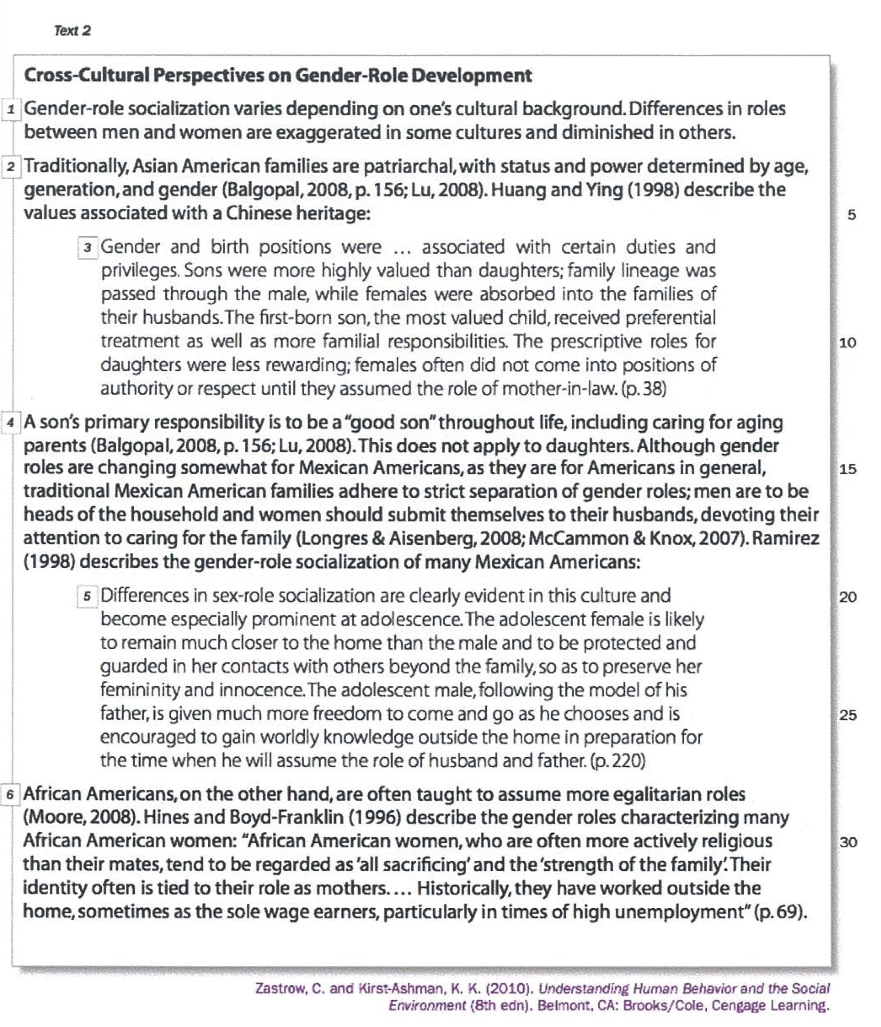

Scan the texts and identify 1the text and section where you can find the following examples. Summarize the information you find in a brief note.

1. A society where gender role differences are relatively limited

text 1, section 1- Tahiti: few differences in expected behavior men vs women.

2.Gender-related characteristics found to be similar across societies

3. The effects of physical differences on gender roles.

4. How boys and girls play differently in same-sex groups.

5. A society where men take responsibility for their ageing parents

6. A society where traditionally a woman becomes part of the husband’s family when she marries.

7. A society where female teenagers’ contacts with people outside the family are carefully controlled

8. A society where gender roles traditionally are clearly differentiated.

9. A society where wives have a more important role than their husbands in holding the family together.

10. A society where women traditionally have gone to work.

