Pre-Reading Activity:

Discuss the following questions as a class:

How do you feel when you have too much work to do?

Does work ever affect your health or relationships? In what way(s)?

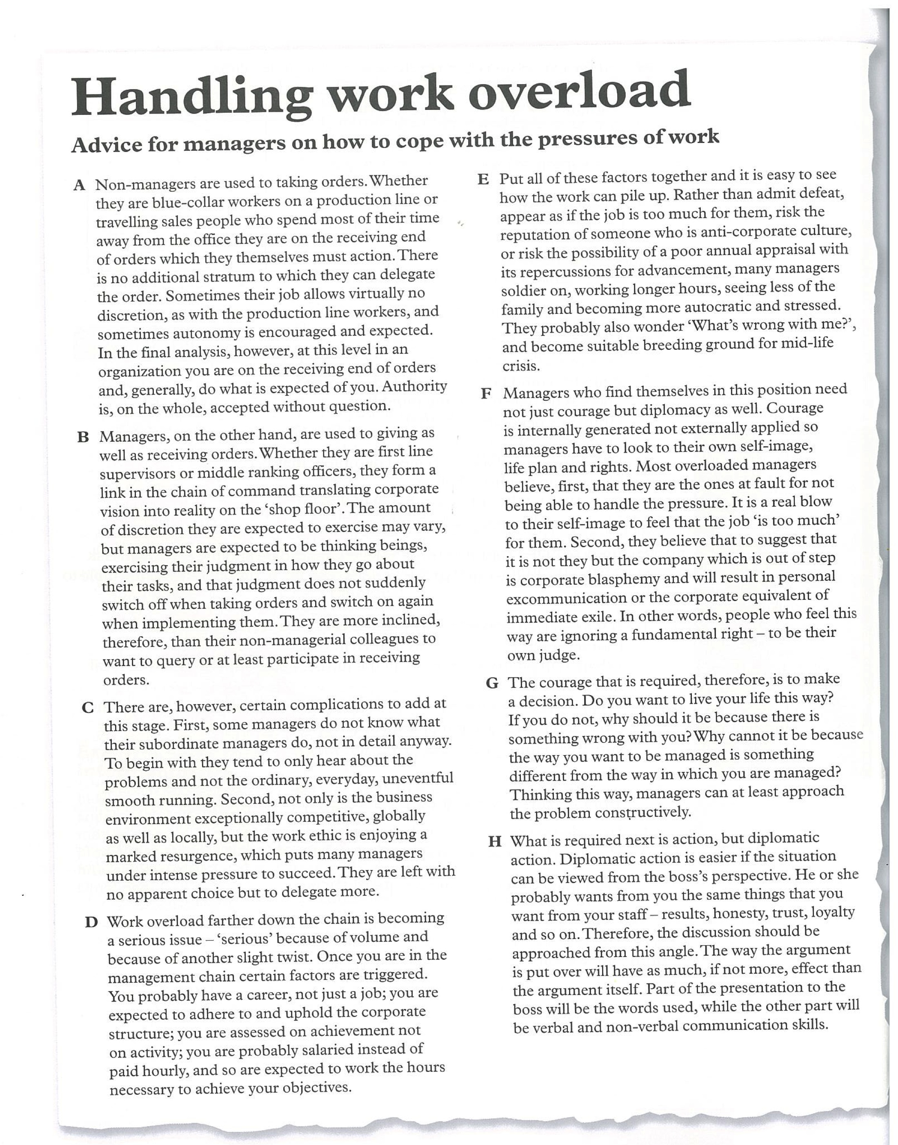
Please read the following article:
Post-Reading Tasks

Note Completion

Questions 1-6

Complete these notes about the passage. Choose NO MORE THAN THREE WORDS from the passage for each answer.

- Non-Managers

Accustomed to 0.)taking orders
No scope for them to 1)__________________________
2)____________________may be possible

- Managers

Accustomed to giving and receiving orders
Expected to interpret and implement the 3)___________________________
of those above them
Expected to use their 4)______________________________
Pressure to succeed may force them to 5)___________________________
May choose to accept too much work rather than 6)_________________________
Overwork may lead to health or family problems.

1
2
3
4
5
6

Yes, No, Not given

Do the following questions agree with the views of the writer? Write:

Yes: if the statement agrees with the views of the writer
No: if the statement contradicts the views of the writer
Not Given: if it is impossible to say what the writer thinks about this

7. Only managers question the orders, which they receive.
8. Competition and attitudes to work increase the expectations put on managers.
9. Managers worry about the effect their work has on family life.
10. Managers should give constructive feedback to their superiors.

Matching Details to Paragraphs

Strategy:

Scan read the passage for vocabulary repetition or parallel expressions in the question and passage. Use these to help you to match details and paragraphs

The passage has eight paragraphs A-H. Which paragraph contains the following information? Write the correct letter A-H next to the question.

The words in italics appear in the passage or are a synonym for an expression in the passage. Use them to help you to answer the questions.

11. What managers want from the people who work for them___________
12. What managers may believe about themselves___________
13. Effects on managers of not discussing an excessive workload with their manager__________
14. Advice on how managers can change their thinking____________
15. How managers’ performance is evaluated______________

