Study the diagram below and answer these questions:

- How many disease groups does the diagram show?

- What do the figures in the left- and right- hand columns represent?

- Write an introductory sentence?

Answer the following questions

- Which disease group kills most people in the more economically developed world?

- Which disease group kills most people in the less economically developed world?

- In which disease group is there the biggest difference between the two areas?

Complete the extracts using information from the diagram below:

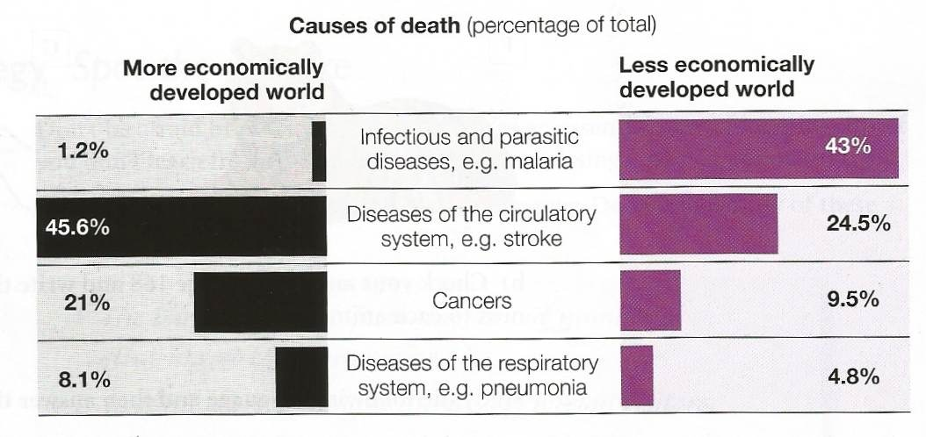

- Infections and parasitic diseases cause 1)___________________________________ 50% of deaths in the less economically developed countries. 2)_________________________, these diseases account for only 3)________________________________ of deaths in the more economically developed world.
- Diseases of the circulatory system are the biggest killers in the more economically developed world 4)_________________________________________ infections and parasitic diseases 5)_______________________________________ the majority of deaths in the less economically developed world.

Independent Exercises

Using your writing strategies summarize the characteristics of the following bar chart

