Predictions when reading:

In order to be good at making predictions in readings use the following:

- The title and subtitle and any illustrations
- Your knowledge of the world and the topic.

- Discuss and the following questions:

- What do you know about McDonald’s?

- Do you think McDonald’s is large enough to influence what and how much food is produced in the United States?

- Look at the title and subtitle of the article. Before you read the passage predict the answers to questions 1-2.

- The writer’s purpose is to:
- Present a problem and a solution
- Describe a cause and an effect
- Present one side of an argument
- Present both sides of an argument

- The passage describes McDonald’s recent impact on:
- Advertising
- Beef farming
- Apple growing
- Restaurant menus

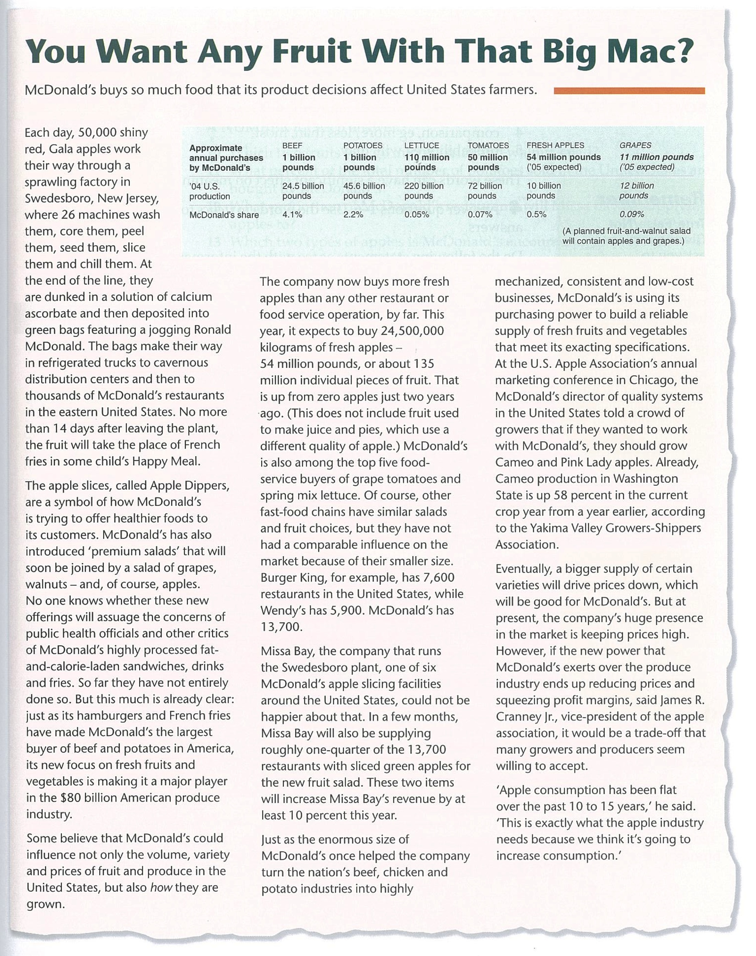

True False Not Given:

Things to remember and tips:

- True / False / Not Given questions ask you to identify whether a statement agrees with or contradicts information in a passage.
- Always pay special attention to words in the questions and passage which shown
        - Number or amount e.g. every, half, a few, few
        - Time or frequency e.g. always, already
        - Negativity e.g. not, none
        - Comparison e.g. more / less than, most
        - Probability e.g. will, many

Answer questions 1-6. Use the italics to help you find the answers.

Do the following statements agree with the information given in the passage?

Write:
True | If the statement agree with the information
False | If the statement Contradicts the information
Not Given | If there is no information on this

- McDonald’s has already introduced salads with fruit.
- The introduction of fruit and produce into McDonald’s menu may reassure health officials.
- Criticism of the calorie and fat content of McDonald’s food has affected sales.
- Other fast food chains have not affected food production.
- Missa Bay’s income is predicted to rise by less than 10%
- McDonald’s has influenced the efficiency of parts of the Amercian food produced producing industry.

Flow Chart Completion

Answer questions 7-9

Complete the flow chart. Use no more than Two Words and/or a Number from the passage for each answer.

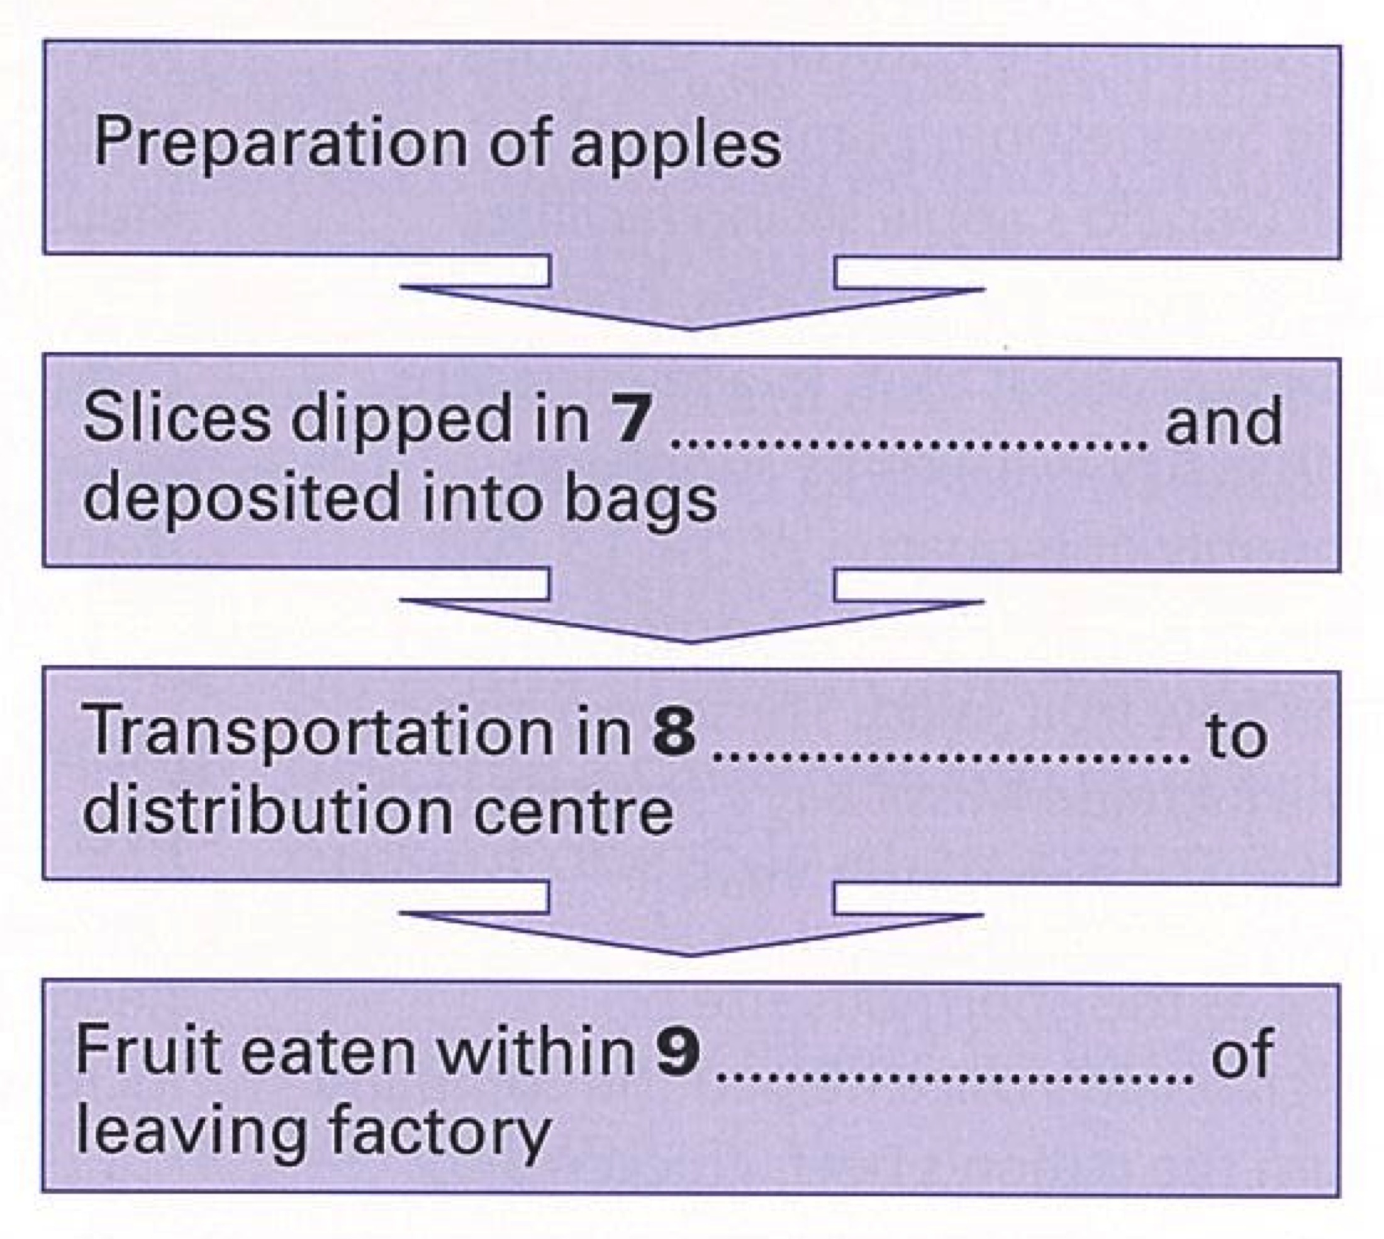

Short Answer Questions

Answer the questions. Write No More Than Three Words And/or A number for each Answer.

10. Which two fruits will go into the fruit and walnut salad?

11. What percent of the total number of potatoes sold in the United States are bought by McDonald’s?

12. What proportion of McDonald’s restaurants will Missa Bay be supplying apples to?

13. Which two types of apple is McDonald’s encouraging growers to produce?

10
11
12
13

