Summarize the following flowchart describing the process of waste paper recycling

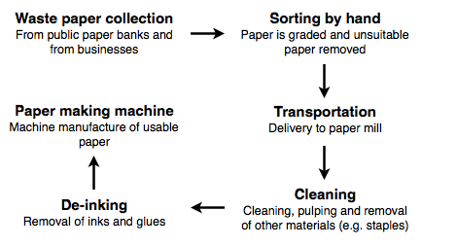

Use the following plan to help you plan out your essay

Paragraph 1:
Introduce the flow chart

Paragraph 2:
Summarize the main steps of the process

Paragraph 3:
Concluding Statement (restate the introduction)

