Name
Date
Section
Score

Using the information in the graph below write a report summarizing the information shown below

- Please remember that you should write at least 150 words

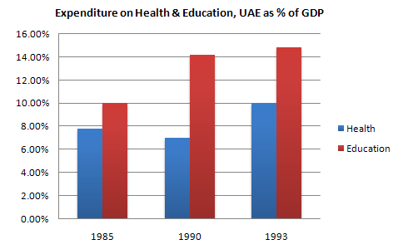

Using the information in the graph below write a report summarizing the information shown below

- Please remember that you should write at least 150 words
