Look at the graph below

1. Which country has the highest level of pollution?
2. Which country has the lowest?

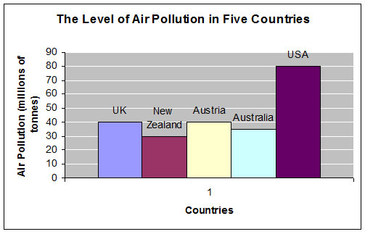

Using the “Information Overview Knowledge” structure and comparative language write a 150 response summarizing the data in the graph

